E-Commerce Customer Churn Analysis
Detailed SQL Solution Report
Module-End Assignment — MySQL
Database: ecomm | Table: ecommerce_data

1. Introduction & Approach
This report documents the complete solution to the E-Commerce Customer Churn Analysis assignment, covering data cleaning, data transformation, seventeen analytical queries, and a “supplementary returns” table. Every SQL statement is reproduced exactly as it should be run in MySQL, immediately followed by a plain-English explanation of the logic behind it — what the query is doing, why that approach was chosen, and any assumptions made where the assignment wording was ambiguous.
The solution assumes the cleaned dataset lives in a table called ecommerce_data inside a database called ecomm, with the original column names as supplied in the raw dataset: CustomerID, Churn, Tenure, PreferredLoginDevice, CityTier, WarehouseToHome, PreferredPaymentMode, Gender, HourSpendOnApp, NumberOfDeviceRegistered, PreferedOrderCat, SatisfactionScore, MaritalStatus, NumberOfAddress, Complain, OrderAmountHikeFromlastYear, CouponUsed, OrderCount, DaySinceLastOrder, and CashbackAmount.
The report follows the same three-part structure as the assignment brief: Data Cleaning, Data Transformation, and Data Exploration & Analysis, followed by the customer_returns table task.

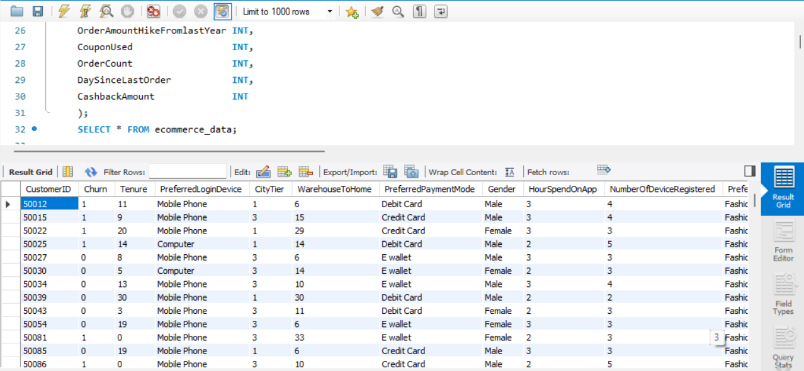

2. Data Cleaning
Data cleaning addresses three problems in the raw dataset: missing values, an outlier in WarehouseToHome, and inconsistent category labels. Each fix is applied directly to the table with UPDATE and DELETE statements so the cleaned data can feed directly into later analysis.

2.1 Imputing the Mean for Numeric Columns
Four continuous columns — WarehouseToHome, HourSpendOnApp, OrderAmountHikeFromlastYear, and DaySinceLastOrder — have their missing (NULL) values filled with the column's mean, rounded to the nearest integer.
UPDATE ecommerce_data
SET WarehouseToHome = (
SELECT avg_val FROM (
SELECT ROUND(AVG(WarehouseToHome)) AS avg_val
FROM ecommerce_data
) AS t
)
WHERE WarehouseToHome IS NULL;

-- (Repeated in the same pattern for HourSpendOnApp,
-- OrderAmountHikeFromlastYear, and DaySinceLastOrder)
Explanation: MySQL's AVG() function automatically ignores NULL values, so the inner subquery computes the true mean of only the rows that already have data, and ROUND() rounds it to the nearest whole number as the assignment requires. The result is then written into every row where the column is currently NULL. Because MySQL does not allow a table to be updated while simultaneously being read from in the same statement, the inner SELECT is wrapped in an extra derived table — SELECT avg_val FROM (SELECT AVG(...) AS avg_val FROM table) AS t — which forces MySQL to fully compute and materialize the average before the UPDATE begins, sidestepping the restriction. The same four-line pattern is repeated once per column, changing only the column name.

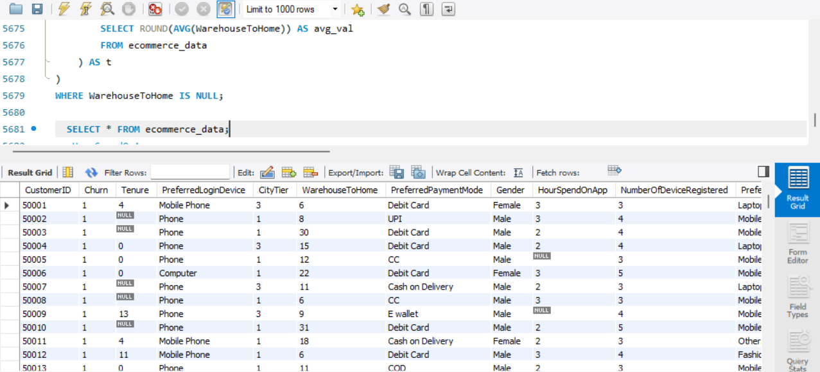
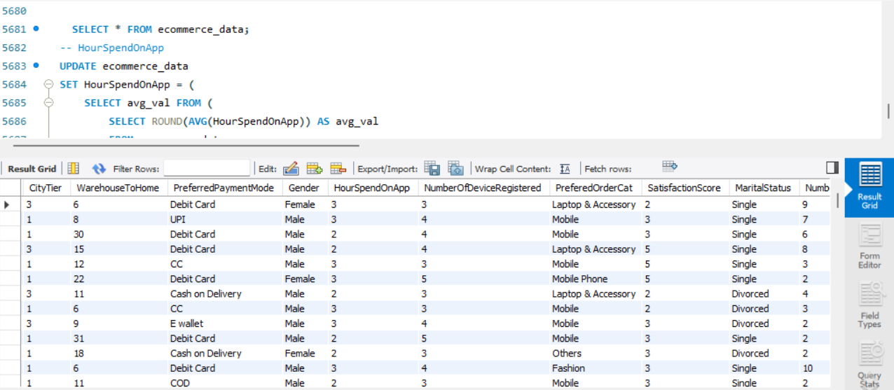

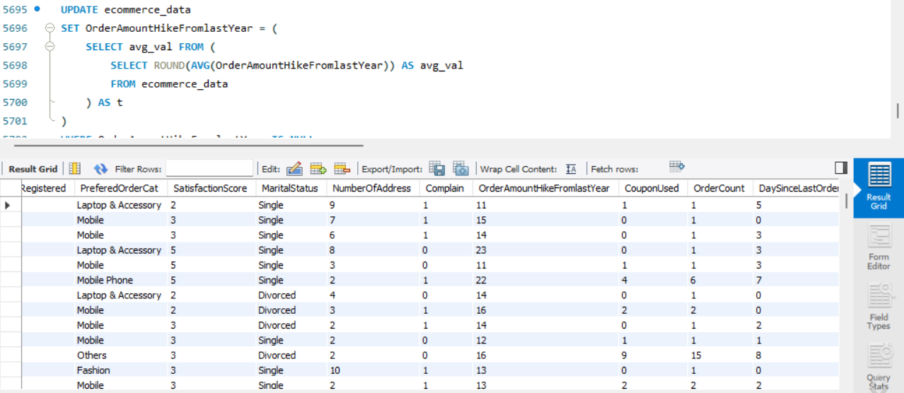

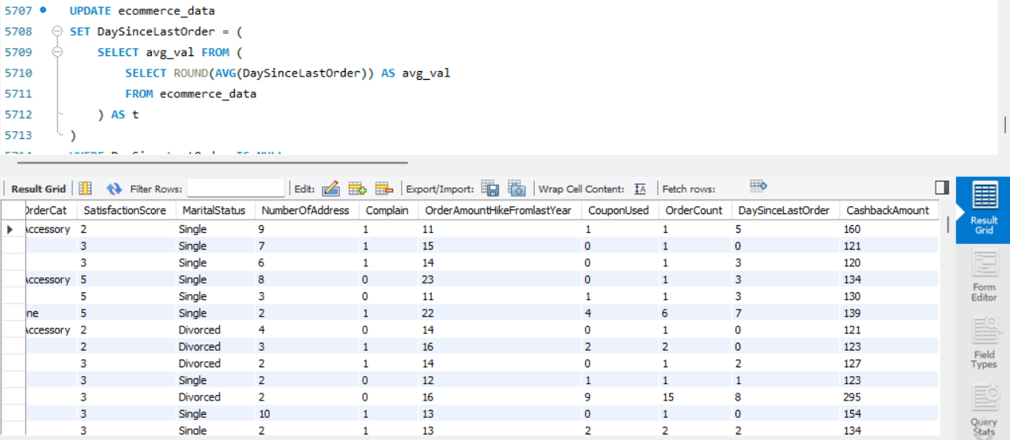

2.2 Imputing the Mode for Discrete Columns
Tenure, CouponUsed, and OrderCount are filled with their mode — the single most frequently occurring value — rather than a mean, since these are more naturally treated as discrete/categorical counts.
UPDATE ecommerce_data
SET Tenure = (
SELECT val FROM (
SELECT Tenure AS val, COUNT(*) AS cnt
FROM ecommerce_data
WHERE Tenure IS NOT NULL
GROUP BY Tenure
ORDER BY cnt DESC
LIMIT 1
) AS mode_tbl
)
WHERE Tenure IS NULL;

-- (Repeated for CouponUsed and OrderCount)
Explanation: The inner query groups all non-NULL values of the column and counts how many rows fall into each value with GROUP BY ... COUNT(*). Sorting that result by count in descending order and taking only the first row with ORDER BY cnt DESC LIMIT 1 isolates the mode — the value that appears most often. As with the mean imputation, this is wrapped in a derived table so MySQL will allow it inside an UPDATE that targets the same table, and the resulting single value is written into every NULL cell.

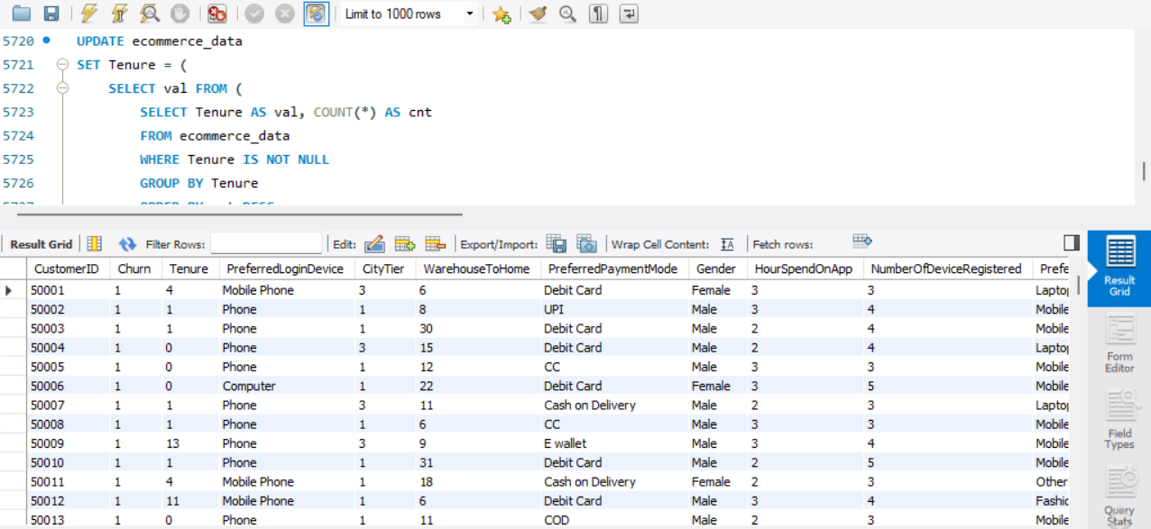

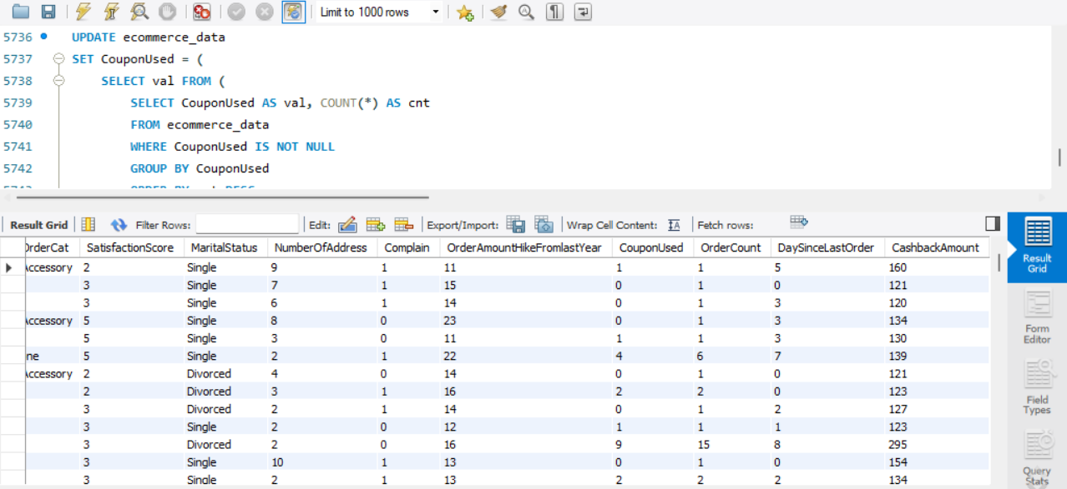
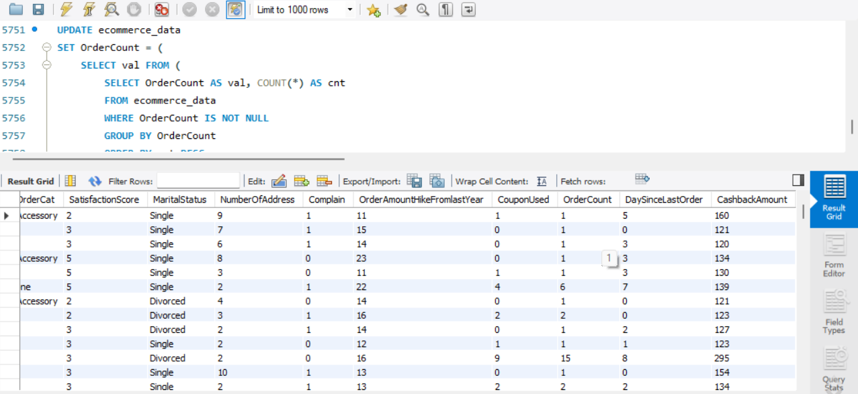

2.3 Handling the WarehouseToHome Outlier
DELETE FROM ecommerce_data
WHERE WarehouseToHome > 100;
Explanation: A straightforward DELETE removes any row where the distance from warehouse to home exceeds 100 (km), since such values are implausible for a typical delivery radius and are treated as data-entry outliers rather than genuine long-distance customers. This step should run after the mean imputation for WarehouseToHome, so that the imputed rows (which use a legitimate average) are not themselves mistaken for outliers, and so the deletion is based on real, exceptional values only.
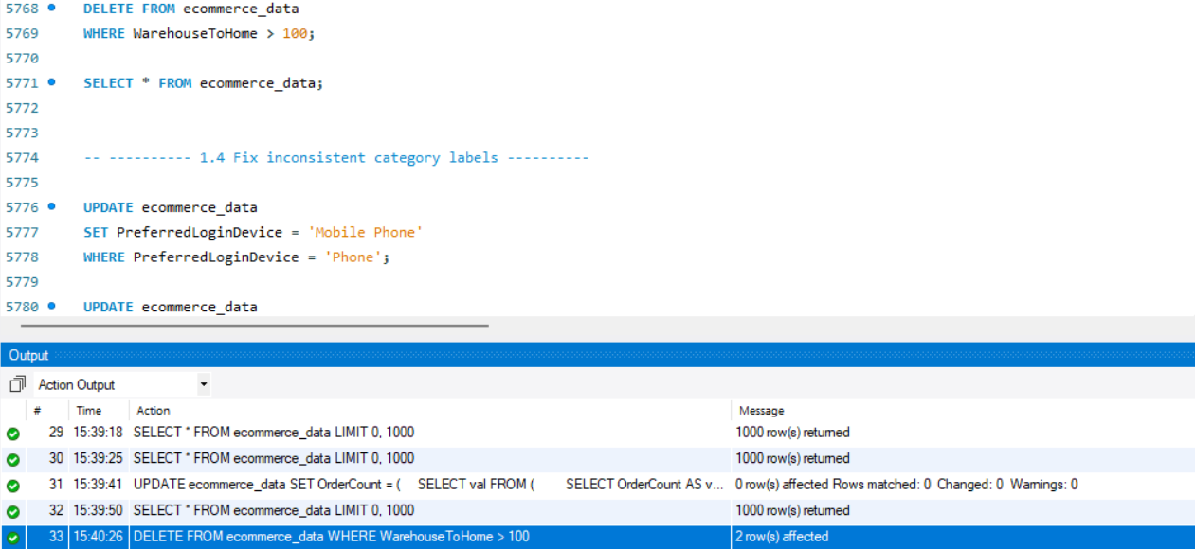

2.4 Standardising Inconsistent Category Labels
UPDATE ecommerce_data
SET PreferredLoginDevice = 'Mobile Phone'
WHERE PreferredLoginDevice = 'Phone';

UPDATE ecommerce_data
SET PreferedOrderCat = 'Mobile Phone'
WHERE PreferedOrderCat = 'Mobile';

UPDATE ecommerce_data
SET PreferredPaymentMode = 'Cash on Delivery'
WHERE PreferredPaymentMode = 'COD';

UPDATE ecommerce_data
SET PreferredPaymentMode = 'Credit Card'
WHERE PreferredPaymentMode = 'CC';
Explanation: These four independent UPDATE statements each rewrite one inconsistent label to its standard form: "Phone" becomes "Mobile Phone" in the login-device column, "Mobile" becomes "Mobile Phone" in the order-category column, and the payment-mode abbreviations "COD" and "CC" are expanded to their full names. This matters because every later GROUP BY on these columns (payment-mode popularity, device preference, and so on) would otherwise silently split one real-world category into two separate rows in the results — for example, counting "COD" and "Cash on Delivery" as two different payment modes instead of one.

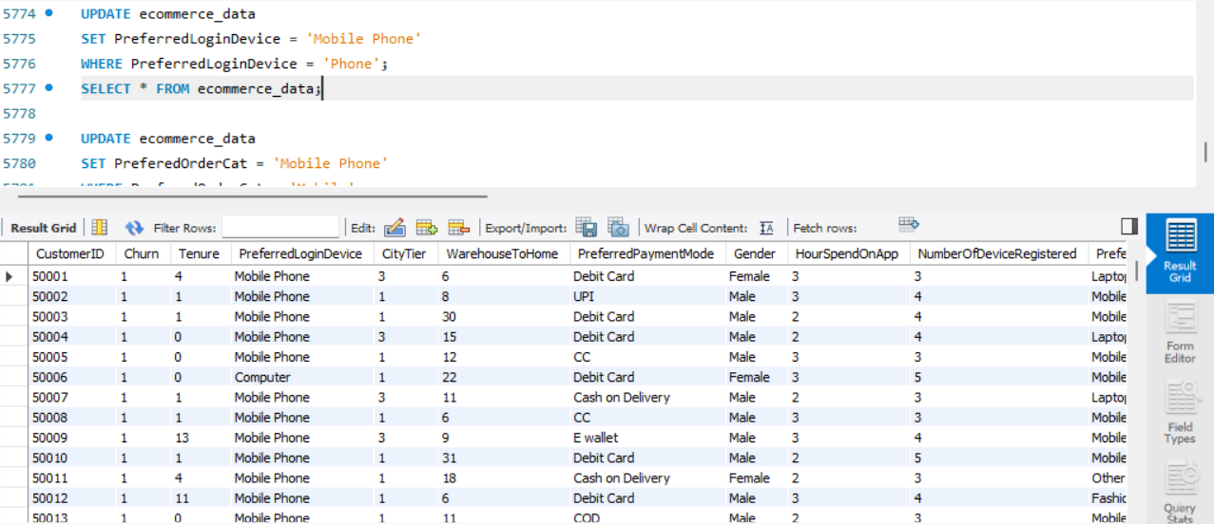

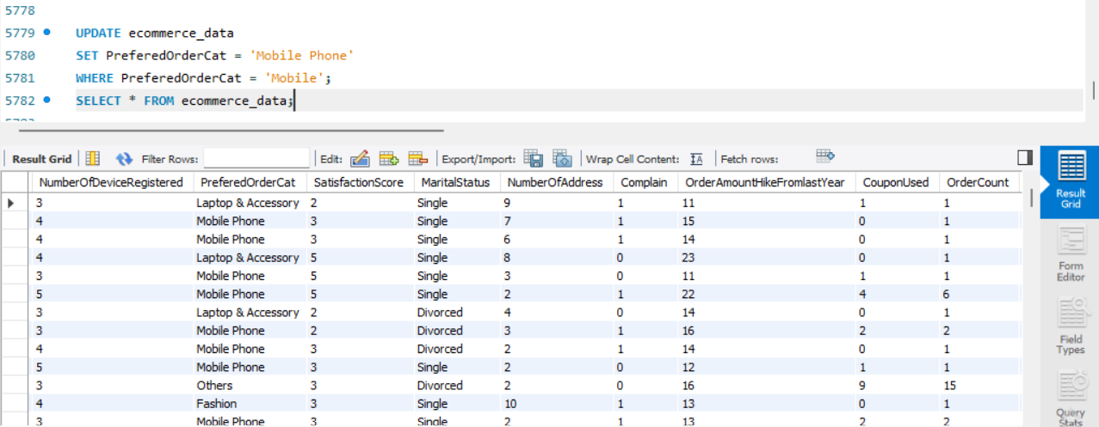

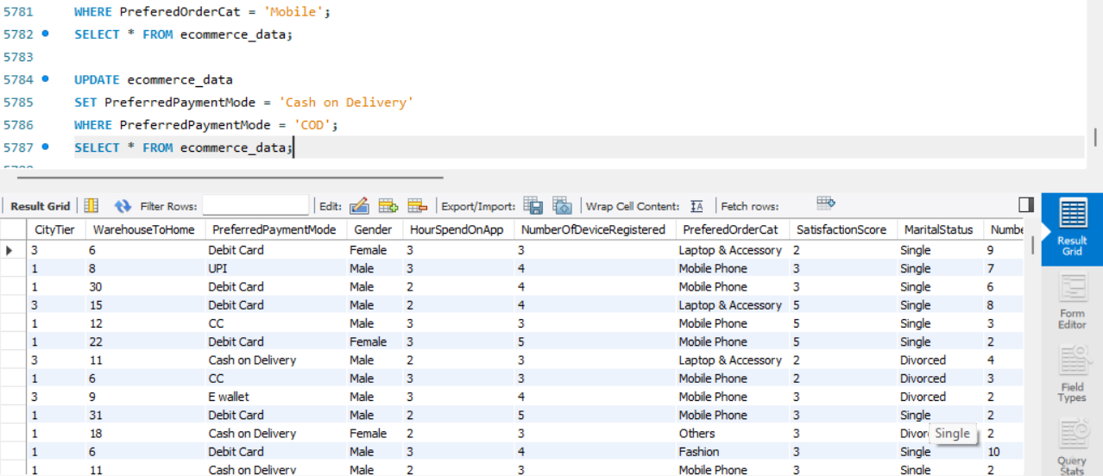

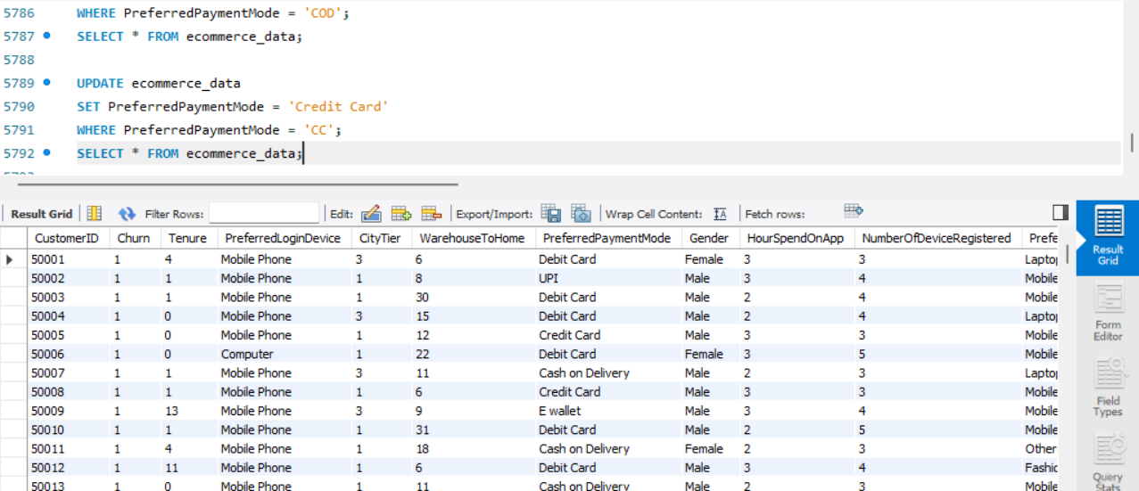

3. Data Transformation

3.1 Renaming Columns
ALTER TABLE ecommerce_data RENAME COLUMN PreferedOrderCat TO PreferredOrderCat;
ALTER TABLE ecommerce_data RENAME COLUMN HourSpendOnApp TO HoursSpentOnApp;
Explanation: MySQL 8.0's RENAME COLUMN clause changes only the column's name while leaving its data type, values, and position untouched. This fixes the original spelling of "PreferedOrderCat" and gives "HourSpendOnApp" clearer, grammatically correct naming. (On MySQL versions earlier than 8.0, the equivalent statement is CHANGE COLUMN old_name new_name <datatype>, which requires re-stating the column's data type.)
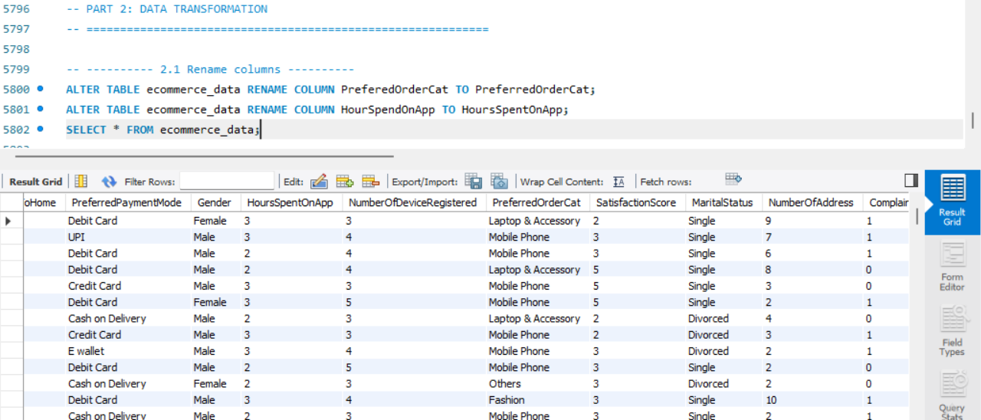

3.2 Creating Derived Columns
ALTER TABLE ecommerce_data ADD COLUMN ComplaintReceived VARCHAR(3);
UPDATE ecommerce_data
SET ComplaintReceived = CASE WHEN Complain = 1 THEN 'Yes' ELSE 'No' END;

ALTER TABLE ecommerce_data ADD COLUMN ChurnStatus VARCHAR(10);
UPDATE ecommerce_data
SET ChurnStatus = CASE WHEN Churn = 1 THEN 'Churned' ELSE 'Active' END;
Explanation: Each new column is created empty with ALTER TABLE ... ADD COLUMN, then populated in a separate UPDATE using a CASE expression that translates the existing binary 0/1 flags into human-readable labels: Complain = 1 becomes "Yes" (otherwise "No"), and Churn = 1 becomes "Churned" (otherwise "Active"). This is done purely for readability in later reporting — every analysis query from this point onward reads ChurnStatus and ComplaintReceived instead of the raw numeric flags.

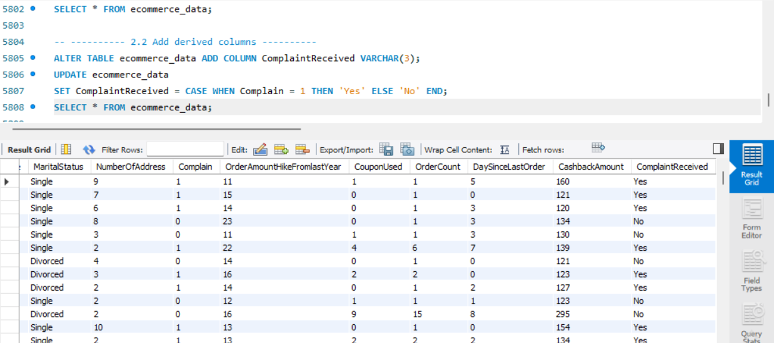

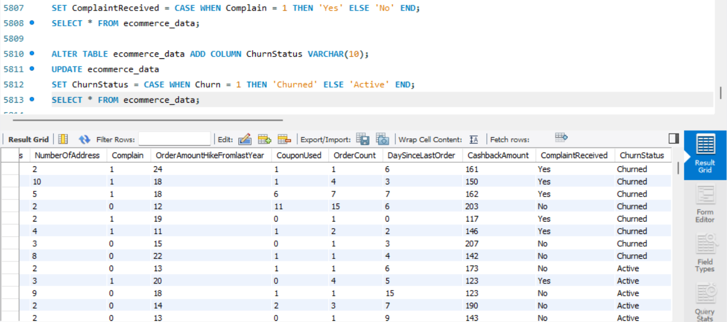

3.3 Dropping the Original Flag Columns
ALTER TABLE ecommerce_data
DROP COLUMN Churn,
DROP COLUMN Complain;
Explanation: Now that ChurnStatus and ComplaintReceived carry the same information in readable form, the original numeric Churn and Complain columns are redundant and are removed with a single ALTER TABLE statement listing both drops. This keeps the schema clean and avoids two columns representing the same fact.
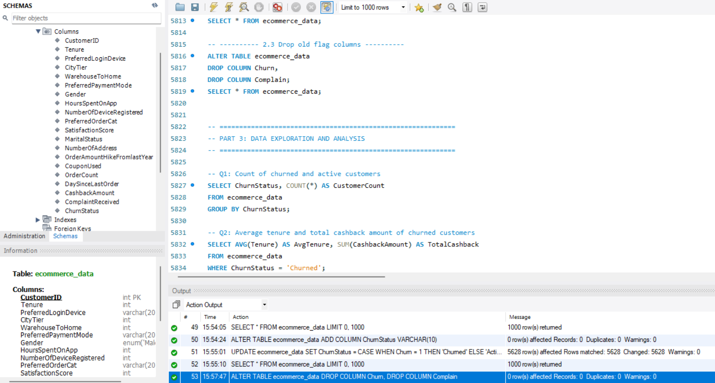

4. Data Exploration & Analysis
Seventeen queries analyse customer behaviour, satisfaction, and churn drivers from different angles. Each one is presented with its full SQL, followed by a walk-through of the logic.

Q1. Retrieve the count of churned and active customers.
SELECT ChurnStatus, COUNT(*) AS CustomerCount
FROM ecommerce_data
GROUP BY ChurnStatus;
Explanation: Groups all rows by the ChurnStatus label and counts how many rows fall into each group, giving a simple two-row summary of Churned vs. Active customer counts.
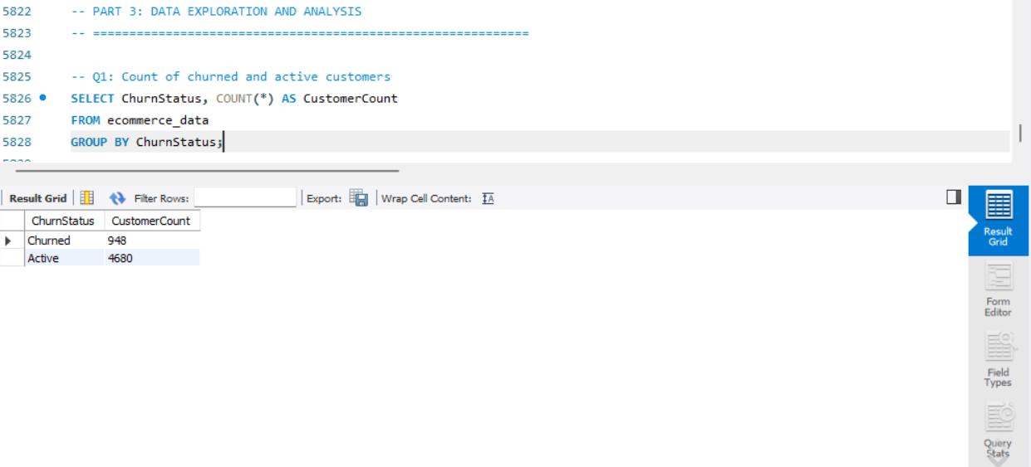

Q2. Display the average tenure and total cashback amount of customers who churned.
SELECT AVG(Tenure) AS AvgTenure, SUM(CashbackAmount) AS TotalCashback
FROM ecommerce_data
WHERE ChurnStatus = 'Churned';
Explanation: The WHERE clause first isolates only churned customers, then two aggregate functions are computed over that filtered set in one pass: AVG() for the mean tenure and SUM() for total cashback paid out to them. No GROUP BY is needed since the whole filtered set is treated as a single group.

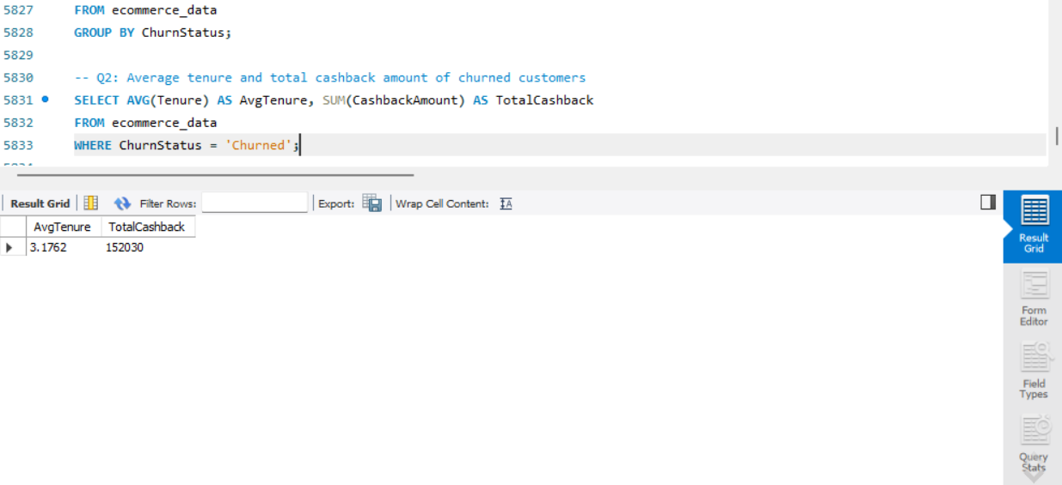

Q3. Determine the percentage of churned customers who complained.
SELECT
SUM(CASE WHEN ComplaintReceived = 'Yes' THEN 1 ELSE 0 END) * 100.0 / COUNT(*)
AS PctChurnedWhoComplained
FROM ecommerce_data
WHERE ChurnStatus = 'Churned';
Explanation: After restricting to churned customers, a CASE expression inside SUM() counts how many of them have ComplaintReceived = 'Yes', which is then divided by the total number of churned customers (COUNT(*)) and multiplied by 100 to express it as a percentage. Multiplying by 100.0 rather than the integer 100 forces MySQL to perform floating-point division so the result keeps its decimal places instead of being truncated.
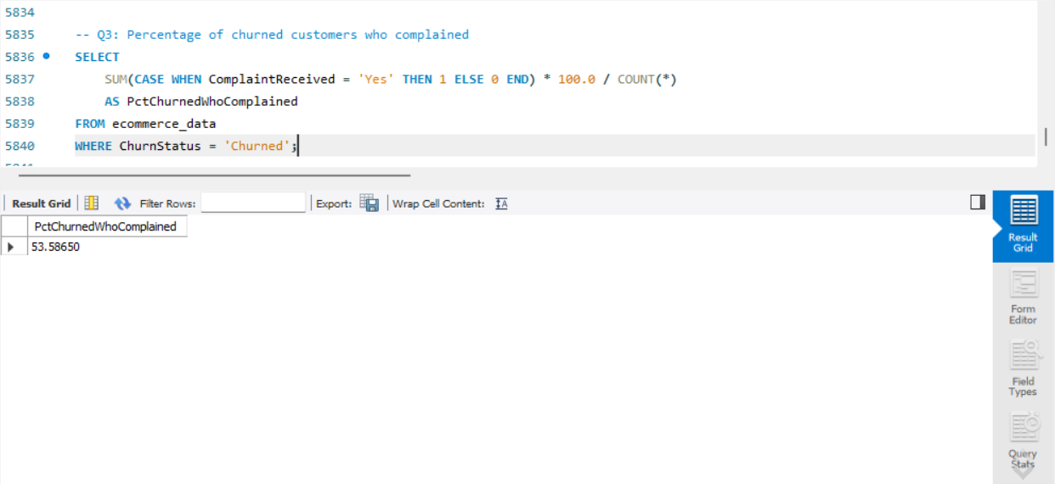

Q4. Identify the city tier with the highest number of churned customers whose preferred order category is Laptop & Accessory.
SELECT CityTier, COUNT(*) AS ChurnedCount
FROM ecommerce_data
WHERE ChurnStatus = 'Churned' AND PreferredOrderCat = 'Laptop & Accessory'
GROUP BY CityTier
ORDER BY ChurnedCount DESC
LIMIT 1;
Explanation: Two conditions are applied together in WHERE — churned status and the Laptop & Accessory category — before the remaining rows are grouped by CityTier and counted. Sorting the counts in descending order and keeping only the top row via LIMIT 1 surfaces the single city tier with the most such churned customers.
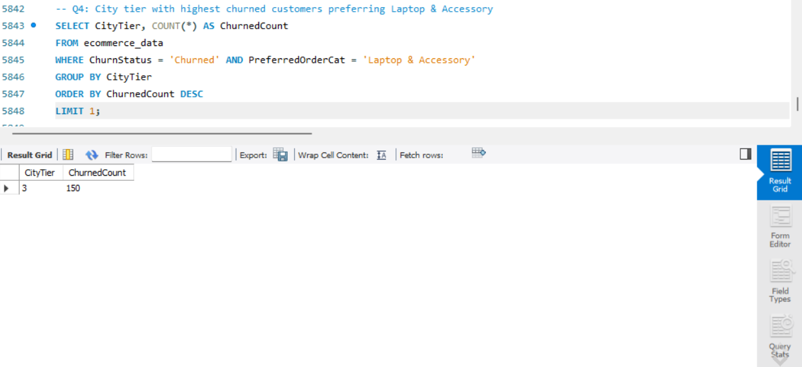

Q5. Identify the most preferred payment mode among active customers.
SELECT PreferredPaymentMode, COUNT(*) AS Cnt
FROM ecommerce_data
WHERE ChurnStatus = 'Active'
GROUP BY PreferredPaymentMode
ORDER BY Cnt DESC
LIMIT 1;
Explanation: The same grouping-and-ranking pattern as Q4 is applied to active customers only, grouping by PreferredPaymentMode instead, to find the single payment mode active customers use most often.
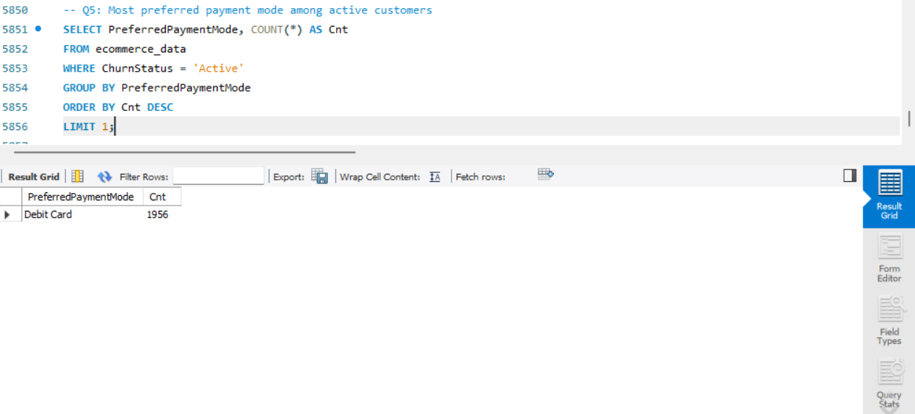

Q6. Calculate the total order amount hike from last year for customers who are single and prefer mobile phones for ordering.
SELECT SUM(OrderAmountHikeFromlastYear) AS TotalHike
FROM ecommerce_data
WHERE MaritalStatus = 'Single' AND PreferredLoginDevice = 'Mobile Phone';
Explanation: Both conditions — MaritalStatus = 'Single' and PreferredLoginDevice = 'Mobile Phone' — are combined with AND, then SUM totals OrderAmountHikeFromlastYear across the matching rows. Assumption: "prefer mobile phones for ordering" is interpreted as the PreferredLoginDevice column (the device used to place orders), rather than PreferredOrderCat, which describes a product category, not an ordering channel.

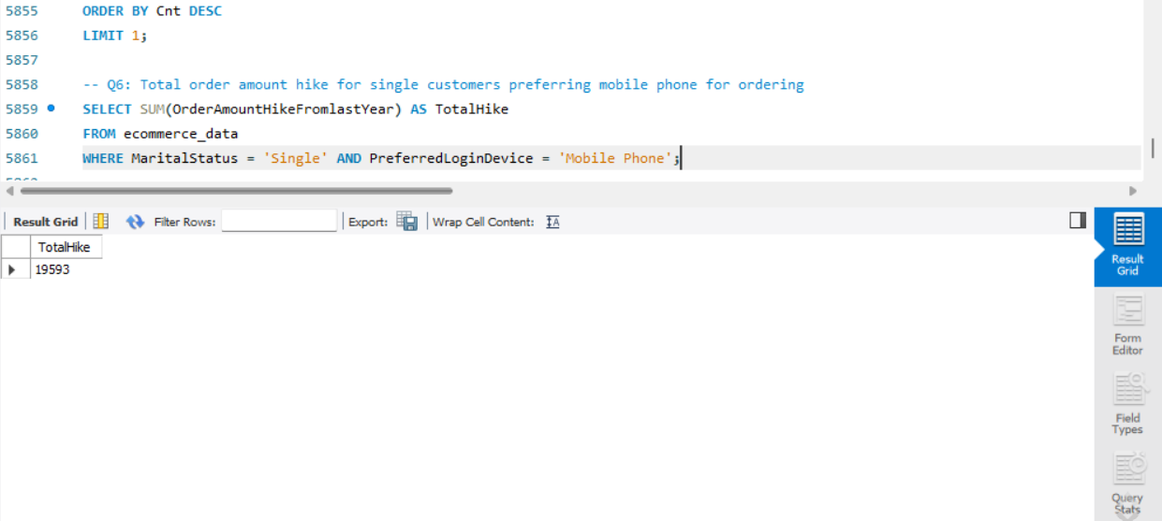

Q7. Find the average number of devices registered among customers who used UPI as their preferred payment mode.
SELECT AVG(NumberOfDeviceRegistered) AS AvgDevices
FROM ecommerce_data
WHERE PreferredPaymentMode = 'UPI';
Explanation: Filters to UPI users only, then averages NumberOfDeviceRegistered across that group in a single aggregate pass.

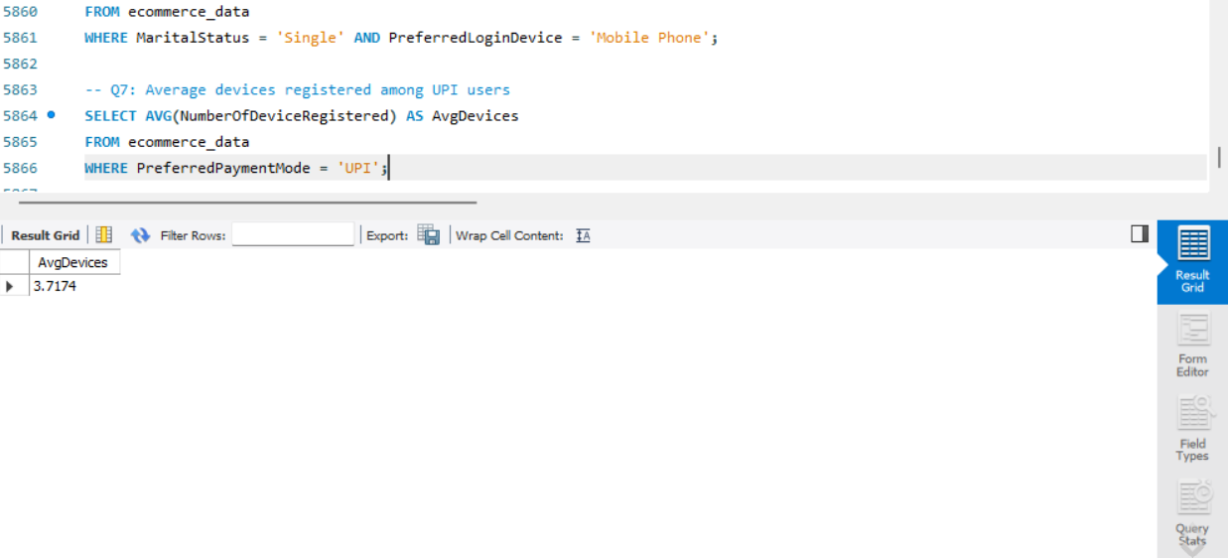

Q8. Determine the city tier with the highest number of customers.
SELECT CityTier, COUNT(*) AS CustomerCount
FROM ecommerce_data
GROUP BY CityTier
ORDER BY CustomerCount DESC
LIMIT 1;
Explanation: Unlike Q4, this counts all customers (no churn or category filter), grouped by CityTier, ranked descending, with the top tier returned via LIMIT 1.
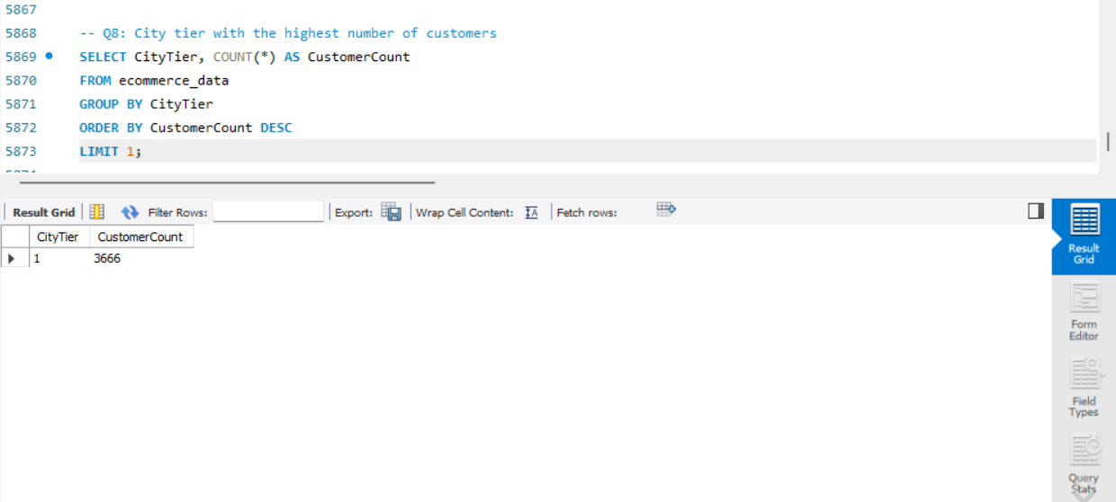

Q9. Identify the gender that utilized the highest number of coupons.
SELECT Gender, SUM(CouponUsed) AS TotalCoupons
FROM ecommerce_data
GROUP BY Gender
ORDER BY TotalCoupons DESC
LIMIT 1;
Explanation: SUM (not COUNT) is used because CouponUsed already stores a quantity per customer rather than a yes/no flag, so grouping by Gender and summing that quantity gives the true total coupons redeemed by each gender; the top one is then isolated with ORDER BY / LIMIT 1.
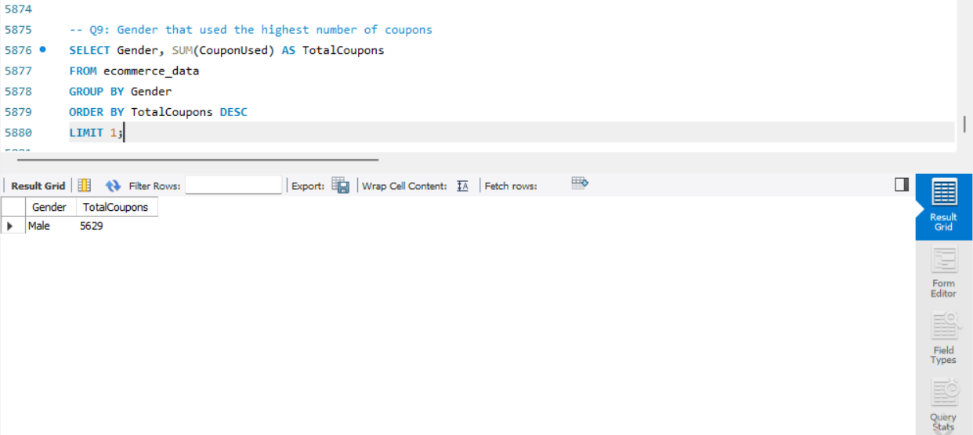

Q10. List the number of customers and the maximum hours spent on the app in each preferred order category.
SELECT PreferredOrderCat, COUNT(*) AS CustomerCount, MAX(HoursSpentOnApp) AS MaxHoursSpent
FROM ecommerce_data
GROUP BY PreferredOrderCat;
Explanation: A single GROUP BY on PreferredOrderCat computes two aggregates per group at once: COUNT(*) for how many customers fall in that category, and MAX() for the highest HoursSpentOnApp value seen within it.

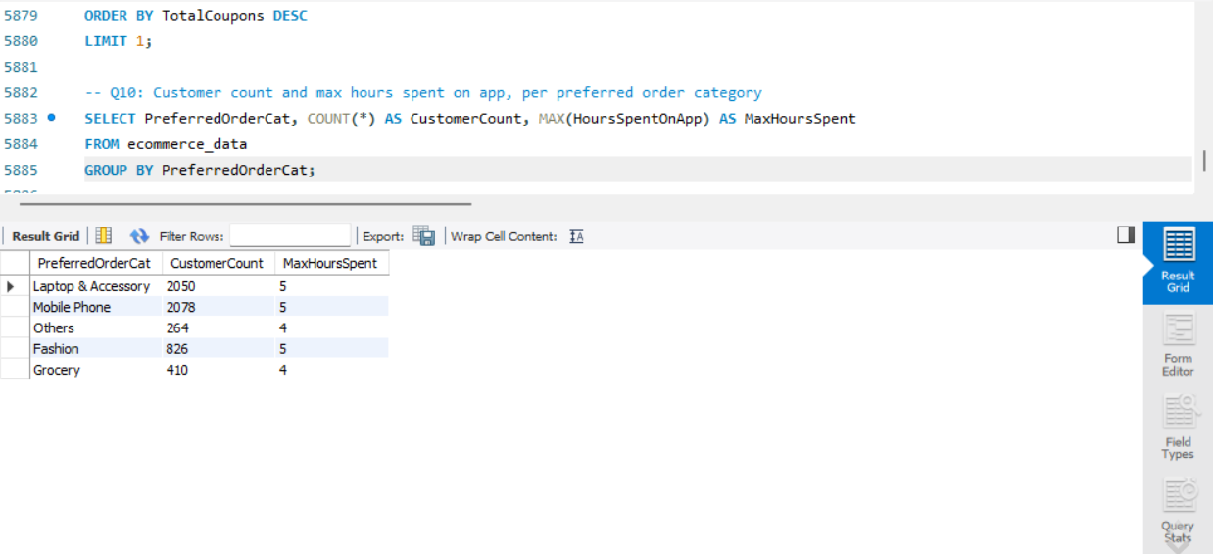

Q11. Calculate the total order count for customers who prefer using credit cards and have the maximum satisfaction score.
SELECT SUM(OrderCount) AS TotalOrders
FROM ecommerce_data
WHERE PreferredPaymentMode = 'Credit Card'
AND SatisfactionScore = (SELECT MAX(SatisfactionScore) FROM ecommerce_data);
Explanation: A scalar subquery, (SELECT MAX(SatisfactionScore) FROM ecommerce_data), first finds the single highest satisfaction score anywhere in the dataset. The outer query then filters to credit-card customers whose own score equals that maximum, and sums their OrderCount.

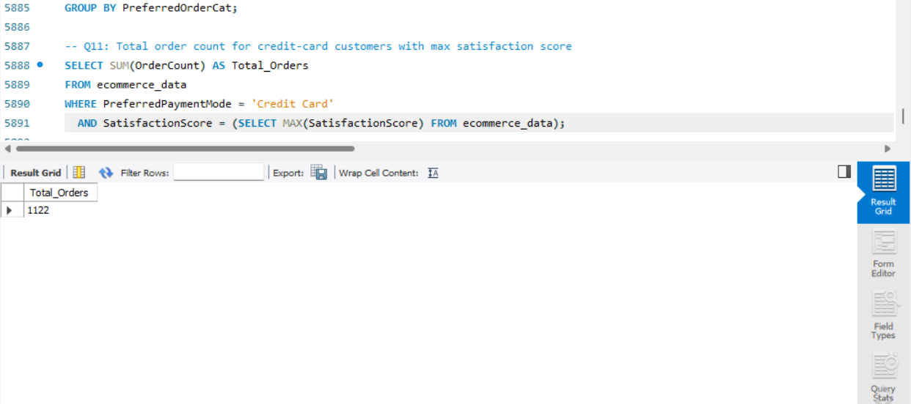

Q12. What is the average satisfaction score of customers who have complained?
SELECT AVG(SatisfactionScore) AS AvgSatisfaction
FROM ecommerce_data
WHERE ComplaintReceived = 'Yes';
Explanation: Filters to customers with ComplaintReceived = 'Yes' and averages their SatisfactionScore — a direct one-condition, one-aggregate query.

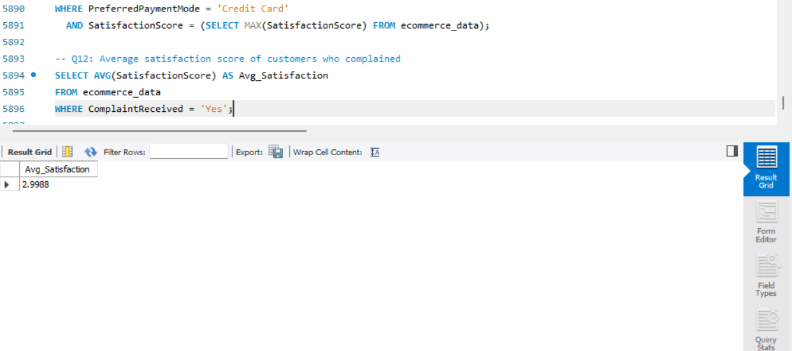

Q13. List the preferred order category among customers who used more than 5 coupons.
SELECT PreferredOrderCat, COUNT(*) AS CustomerCount
FROM ecommerce_data
WHERE CouponUsed > 5
GROUP BY PreferredOrderCat
ORDER BY CustomerCount DESC;
Explanation: Rows are first restricted to CouponUsed > 5, then grouped by PreferredOrderCat and counted. Grouping with a count (rather than a bare DISTINCT list) additionally shows how many heavy-coupon users fall into each category, which is more informative for spotting which category drives the most coupon usage.

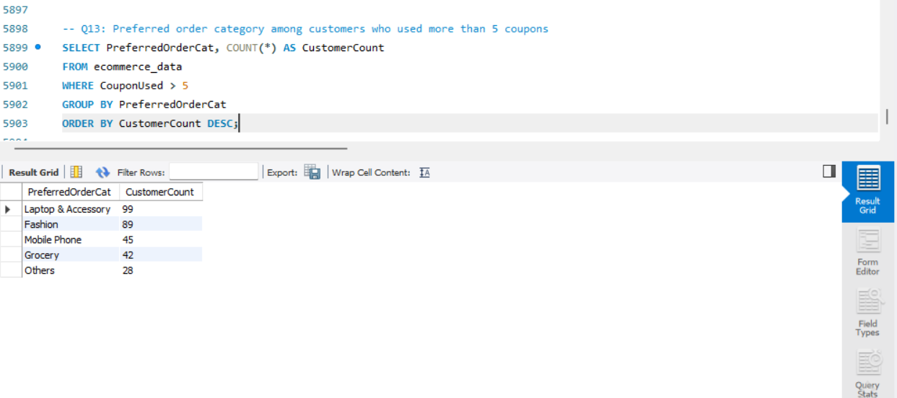

Q14. List the top 3 preferred order categories with the highest average cashback amount.
SELECT PreferredOrderCat, AVG(CashbackAmount) AS AvgCashback
FROM ecommerce_data
GROUP BY PreferredOrderCat
ORDER BY AvgCashback DESC
LIMIT 3;
Explanation: Groups by category, computes the average CashbackAmount per group, sorts those averages from highest to lowest, and keeps only the top three rows with LIMIT 3.

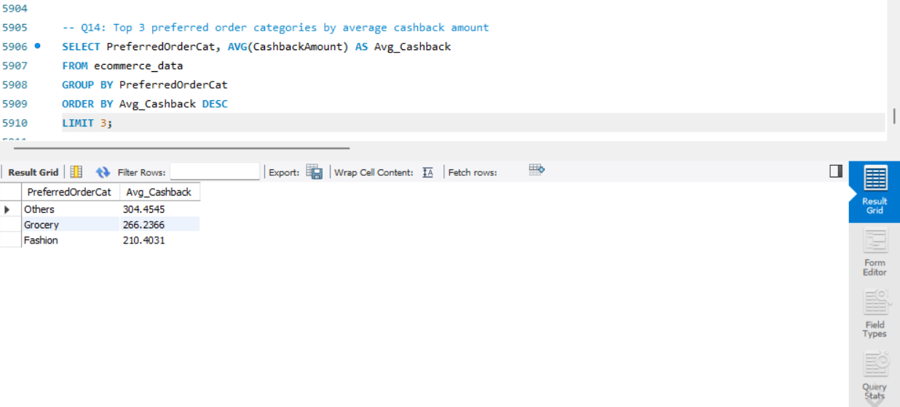

Q15. Find the preferred payment modes of customers whose average tenure is 10 months and have placed more than 500 orders.
SELECT PreferredPaymentMode, AVG(Tenure) AS AvgTenure, SUM(OrderCount) AS TotalOrders
FROM ecommerce_data
GROUP BY PreferredPaymentMode
HAVING AVG(Tenure) = 10 AND SUM(OrderCount) > 500;
Explanation: This query groups customers by PreferredPaymentMode and evaluates two group-level conditions: the group's average Tenure must equal 10, and the group's summed OrderCount must exceed 500. HAVING is required here instead of WHERE because these conditions depend on aggregated values (AVG and SUM) that only exist after the rows have been grouped — WHERE filters individual rows before grouping and cannot reference aggregate functions. Note: if this returns no rows because the average isn't an exact integer 10, consider ROUND(AVG(Tenure)) = 10 as a more tolerant match.

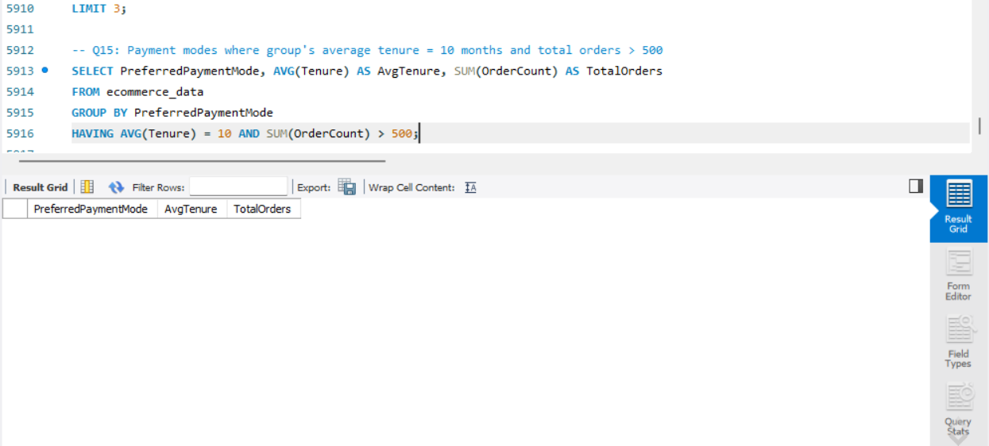

Q16. Categorize customers by warehouse-to-home distance and display the churn status breakdown for each category.
SELECT
CASE
WHEN WarehouseToHome <= 5 THEN 'Very Close Distance'
WHEN WarehouseToHome <= 10 THEN 'Close Distance'
WHEN WarehouseToHome <= 15 THEN 'Moderate Distance'
ELSE 'Far Distance'
END AS DistanceCategory,
ChurnStatus,
COUNT(*) AS CustomerCount
FROM ecommerce_data
GROUP BY DistanceCategory, ChurnStatus
ORDER BY DistanceCategory, ChurnStatus;
Explanation: A CASE expression evaluates each row's WarehouseToHome distance against ascending thresholds (≤5, ≤10, ≤15, and anything above that) and labels it into one of four bands. Because CASE conditions are checked top-to-bottom and stop at the first match, a value of 4 correctly lands in "Very Close Distance" without also matching the ≤10 or ≤15 branches. The result set is then grouped by both the new distance label and ChurnStatus together, so COUNT(*) reports the churned/active split within each distance band rather than one combined total.

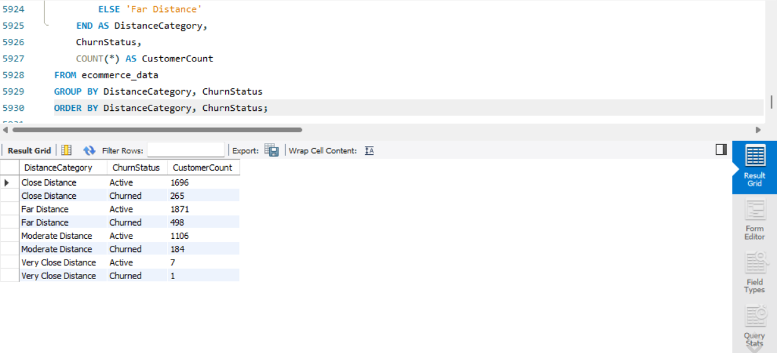

Q17. List the customer's order details who are married, live in City Tier-1, and their order counts are more than the average number of orders placed by all customers.
SELECT *
FROM ecommerce_data
WHERE MaritalStatus = 'Married'
AND CityTier = 1
AND OrderCount > (SELECT AVG(OrderCount) FROM ecommerce_data);
Explanation: The subquery (SELECT AVG(OrderCount) FROM ecommerce_data) computes the overall average order count across every customer in the table — not just married Tier-1 customers — to use as a fair benchmark. The outer query then returns full row details for individual customers who are married, in City Tier 1, and whose own OrderCount exceeds that benchmark.

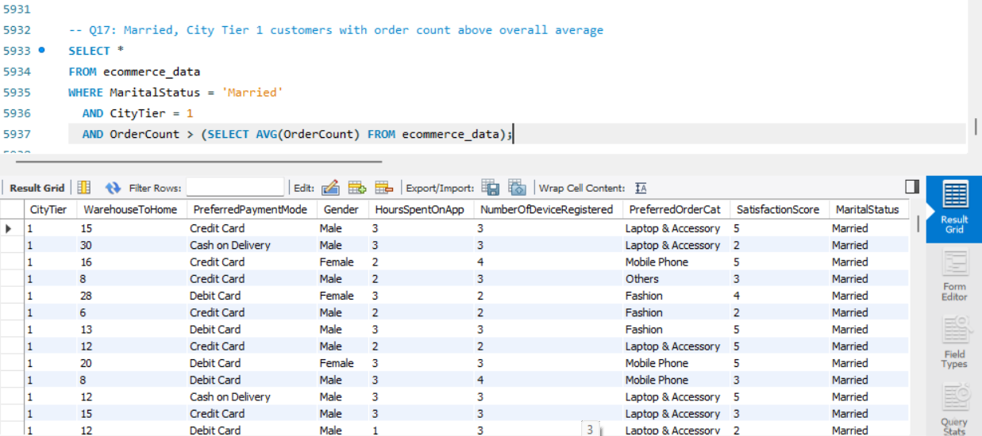

5. Customer Returns Table

5.1 Creating and Populating customer_returns
CREATE DATABASE IF NOT EXISTS ecomm;
USE ecomm;

CREATE TABLE customer_returns (
ReturnID INT PRIMARY KEY,
CustomerID INT,
ReturnDate DATE,
RefundAmount DECIMAL(10,2)
);

INSERT INTO customer_returns (ReturnID, CustomerID, ReturnDate, RefundAmount) VALUES
(1001, 50022, '2023-01-01', 2130),
(1002, 50316, '2023-01-23', 2000),
(1003, 51099, '2023-02-14', 2290),
(1004, 52321, '2023-03-08', 2510),
(1005, 52928, '2023-03-20', 3000),
(1006, 53749, '2023-04-17', 1740),
(1007, 54206, '2023-04-21', 3250),
(1008, 54838, '2023-04-30', 1990);
Explanation: The database is created only if it doesn't already exist, then selected with USE so the following statements run inside it. The table defines four columns matching the assignment's data: ReturnID as an INT PRIMARY KEY since every return has a unique identifier, CustomerID as an INT to link back to the main customer table, ReturnDate as a DATE type for proper date handling and sorting, and RefundAmount as DECIMAL(10,2) to store currency accurately (avoiding the rounding issues that FLOAT can introduce). A single multi-row INSERT statement then loads all eight records in one go.

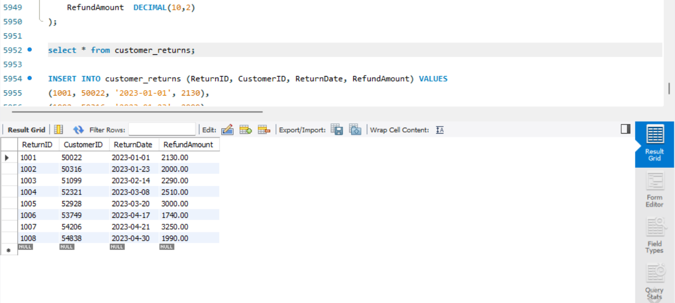

5.2 Returns for Customers Who Churned and Complained
SELECT
r.ReturnID, r.CustomerID, r.ReturnDate, r.RefundAmount,
c.Tenure, c.PreferredPaymentMode, c.PreferredOrderCat,
c.SatisfactionScore, c.ChurnStatus, c.ComplaintReceived
FROM customer_returns r
JOIN ecommerce_data c ON r.CustomerID = c.CustomerID
WHERE c.ChurnStatus = 'Churned' AND c.ComplaintReceived = 'Yes';
Explanation: An INNER JOIN links each row in customer_returns to the matching customer profile in ecommerce_data via CustomerID — only returns that have a corresponding customer record are kept. The WHERE clause then narrows the joined result down to customers who both churned and filed a complaint, surfacing exactly the returns tied to this high-risk, dissatisfied segment. Selecting an explicit column list (rather than SELECT *) keeps the output focused on the fields most relevant to interpreting each return; a full r.*, c.* can be substituted if every column from both tables is wanted instead.
